Adding the Kyocera 5025ci Printers on Windows (7, 8, 8.1, 10)

First, make sure you are connected to the labsmember Wi-Fi network. You cannot print from the Guest network.

Go to dl.hybridge.com and download the Windows drivers for the Kyocera Printer.

Un-zip the file and run the included installer. After selecting “Express Install” it will automatically search for Kyocera printers on the network.
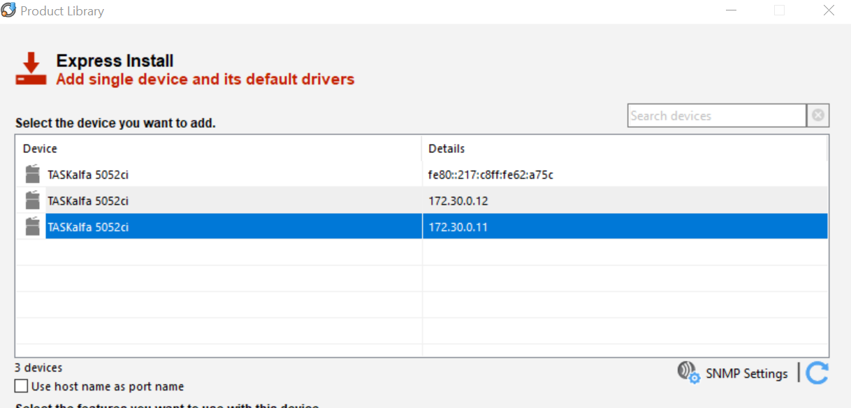

Click on the appropriate printer (each has a label on it with its IP address), and click install on the bottom right. It should automatically go through the rest of the installer and add the printer to your printer list.

If you don’t know which printer to select, they are located in the following locations:
- The blue room: 172.30.0.11
- The magenta room: 172.30.0.12
- 1st floor: 172.30.0.13

If you have any questions or issues involving the printer installation, please feel free to ask Hybridge!

You can contact Hybridge at: Toll Free Support line: 888-353-1763 or support@hybridge.com

