Adding the Kyocera TASKalfa 5025ci Printer on Mac OSX

First, make sure you are connected to the labsmember Wi-Fi network. You cannot print from the Guest network.

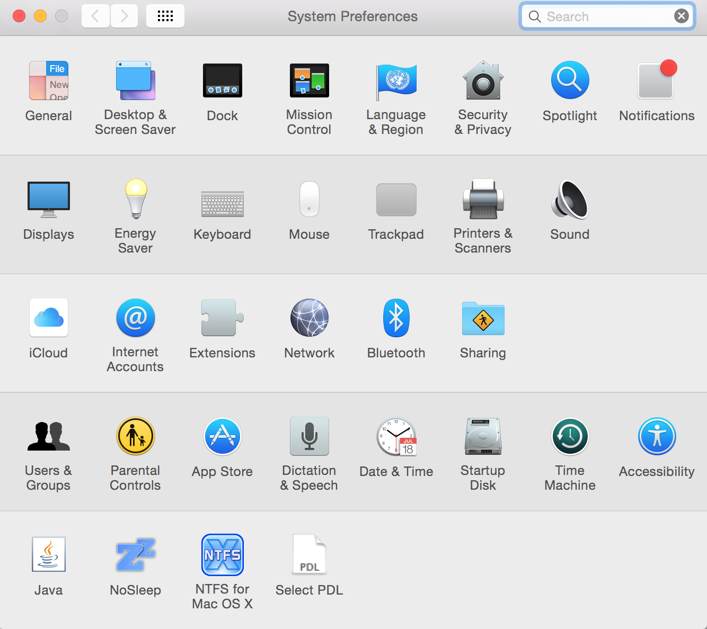
Go to dl.hybridge.com and download the GSV Kyocera Mac drivers. Open the file and run the installer.

Next, go to System Preferences and click on Printers and Scanners.

In that panel, click on the plus on the bottom of the printer list.

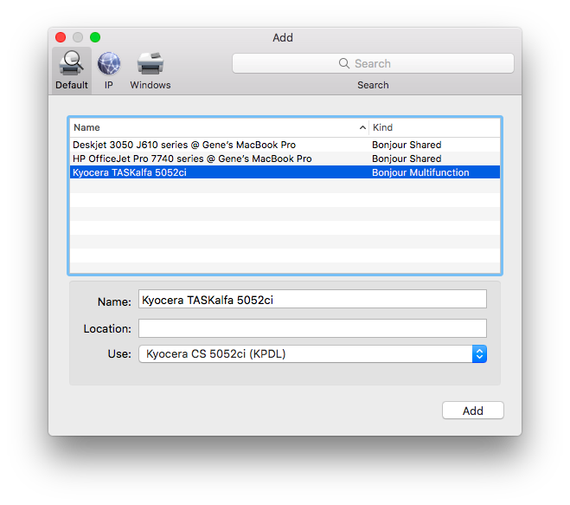

Here you should find the “Kyocera TASKalfa 5025ci 172.30.0.1x”(mirroring the screenshot on the right, where X corresponds to the label on the printer):

Make sure that the Use selection lists the TASKalfa 50525ci printer.

If you don’t know which printer to select, they are located in the following locations:
- The blue room: 172.30.0.11
- The magenta room: 172.30.0.12
- 1st floor: 172.30.0.13

If you have any questions or issues involving the printer installation, please feel free to ask Hybridge!

You can contact Hybridge at: Toll Free Support line: 888-353-1763 or support@hybridge.com

