Adding the Canon iR-ADV C5535 Printer on Windows (7, 8, 8.1, 10)

First, make sure you are connected to the labsMember Wi-Fi network. You cannot print from the Guest network.

Go to https://dl.hybridge.com and download the Windows drivers for the Canon iR-ADV C5535 Printer.

Un-zip the file and run the included installer. After selecting standard installation it will automatically search for Canon printers on the network.
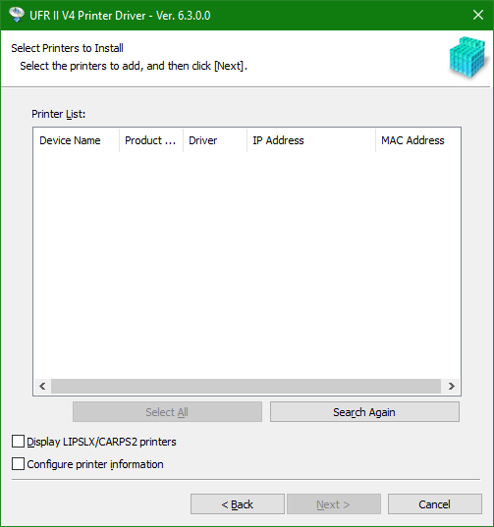

Click on the appropriate printer (the IP should be listed as 172.20.0.5), and click install on the bottom right. It should automatically go through the rest of the installer and add the printer to your printer list.

If you have any questions or issues involving the printer installation, please feel free to ask Hybridge!

Questions? Contact Hybridge IT at: Toll Free Support line: 888-353-1763 or support@hybridge.com

