Adding the Canon iR-ADV C5535 Printer on Mac OSX

First, make sure you are connected to the labsMember Wi-Fi network. You cannot print from the Guest network.

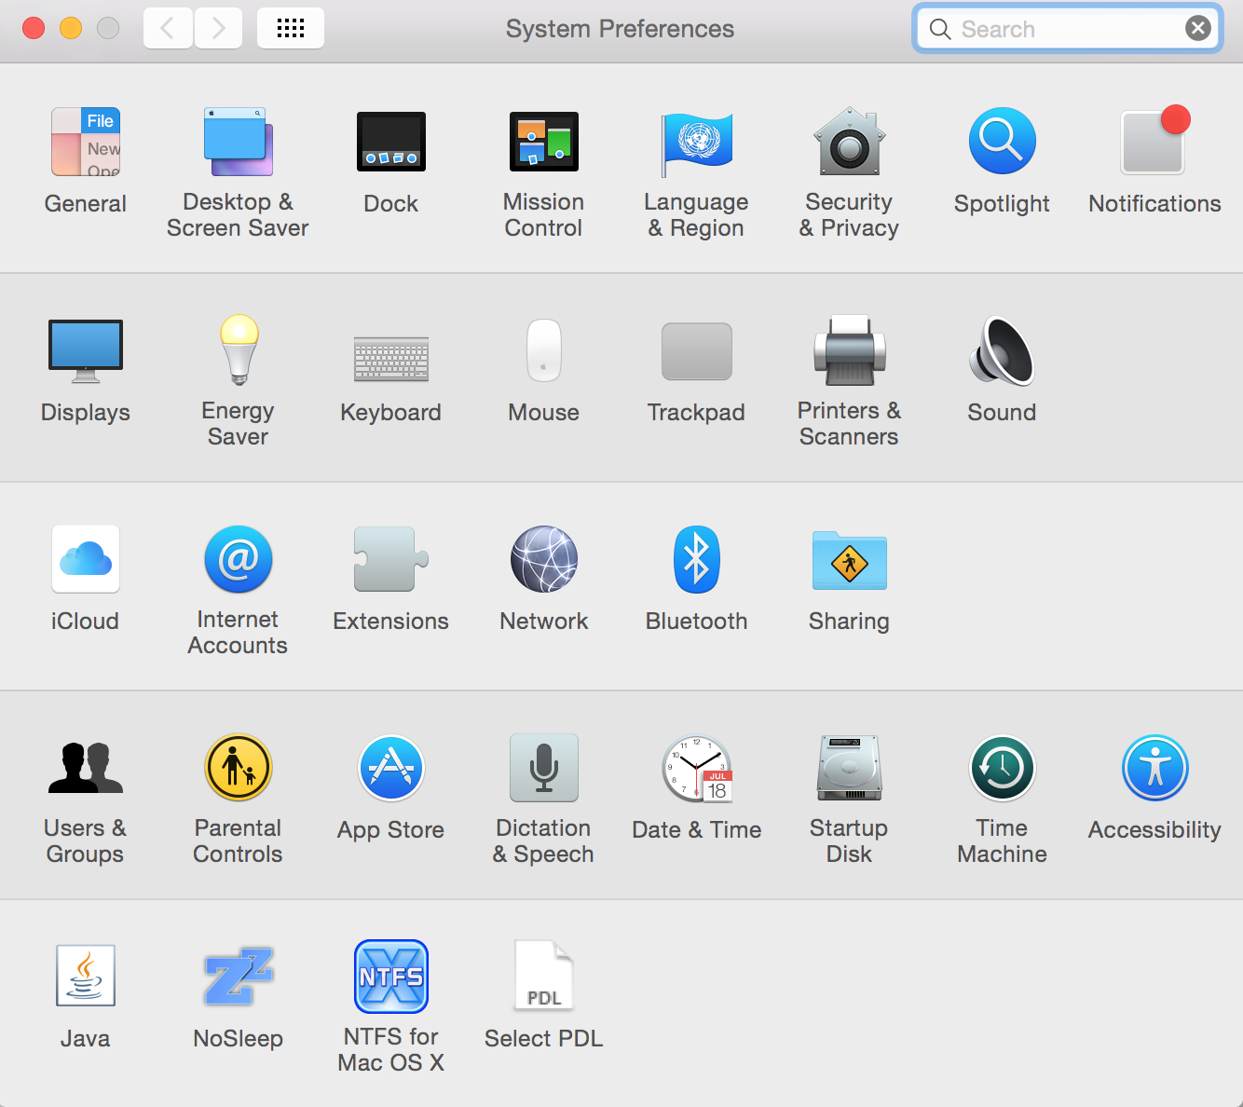
Go to http://dl.hybridge.com/ and download the GSVlabs Boston Canon Mac drivers. Unzip the file, then open and run the installer.

Go to System Preferences and then to “Printers and Scanners”.

Click the + sign in your Printer window to add the printer. You should see the Canon iR-ADV C5535 printer at the bottom of the recognized printers:
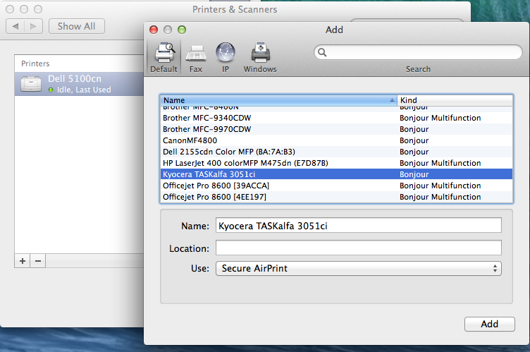

Select the Canon iR-ADV C5535 Printer, click add, and you are done.

If you don’t see the printer listed, double check to make sure you are on the labsMember network, then proceed to the second page:

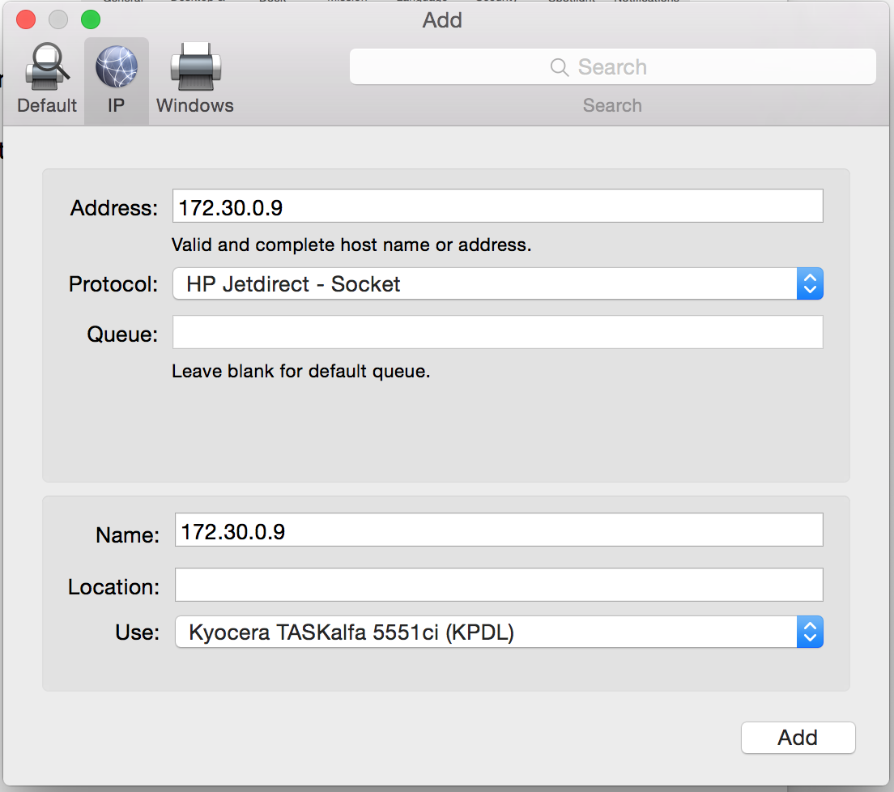
Click on the IP button on top, and enter the following information (mirroring the screenshot on the right):

Address: 172.20.0.5

Protocol: HP Jetdirect – Socket

Make sure that the “Use” selection lists the Canon iR-ADV 5535. If it does not go through the drop down, click “Select Software” and search for Canon iR-ADV 5535. You can change the “Name” field to whatever you would like to see the printer as in your menus.

Questions? Contact Hybridge IT at: Toll Free Support line: 888-353-1763 or support@hybridge.com

